ETHICAL SOFTWARE Community
Teeworlds

Table of contents

Installation 1
Installing with “Software” 2
Installing with Terminal 6

Installation
The ways to install this game

Installing with “Software”

Step 1. First, on your Fedora, move your mouse to the top-left corner of your screen.
You should see the following screen:
Example Output:
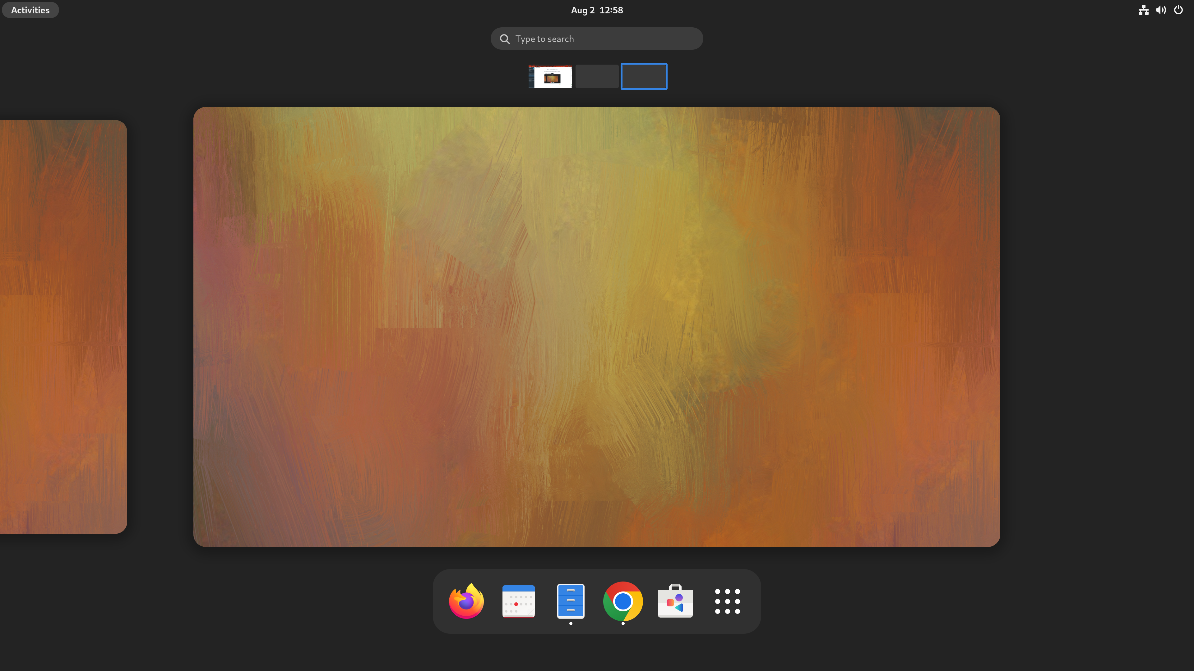
Step 2. Follow the Blue Arrow and Left Click on the “Software” app store Icon :
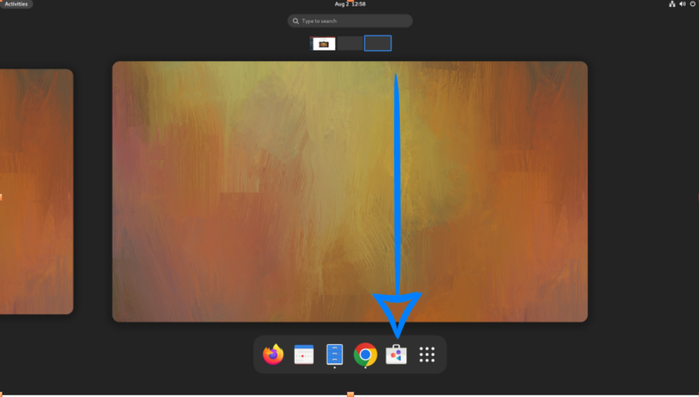
Example Output:
Step 3. You should see the following “Software” store screen.
Example Output:
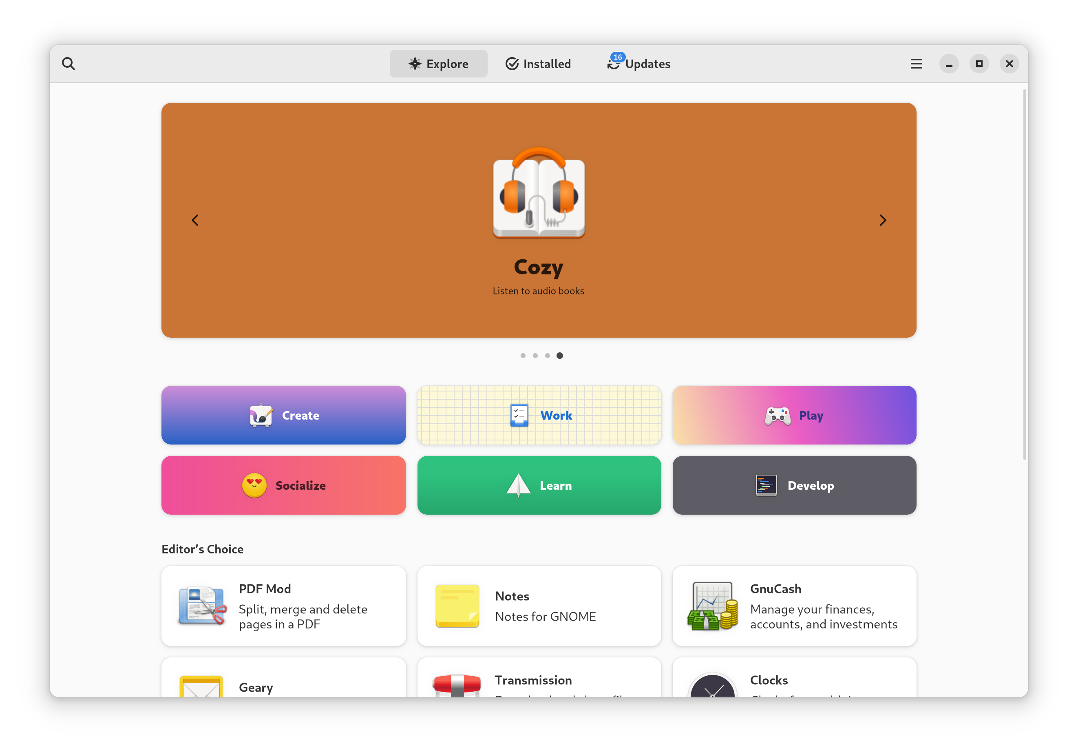Step 4. Left Click the search button on the top-left corner of the “Software” store. Afterwards, we can type in “music midi” in the search bar.
Example Output:
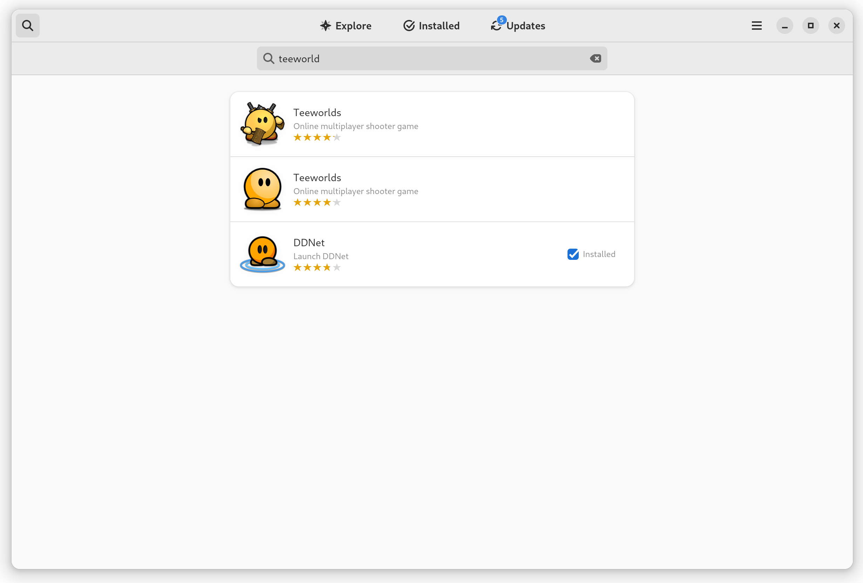

Step 5. Left Click and choose the first one appear in the search result.
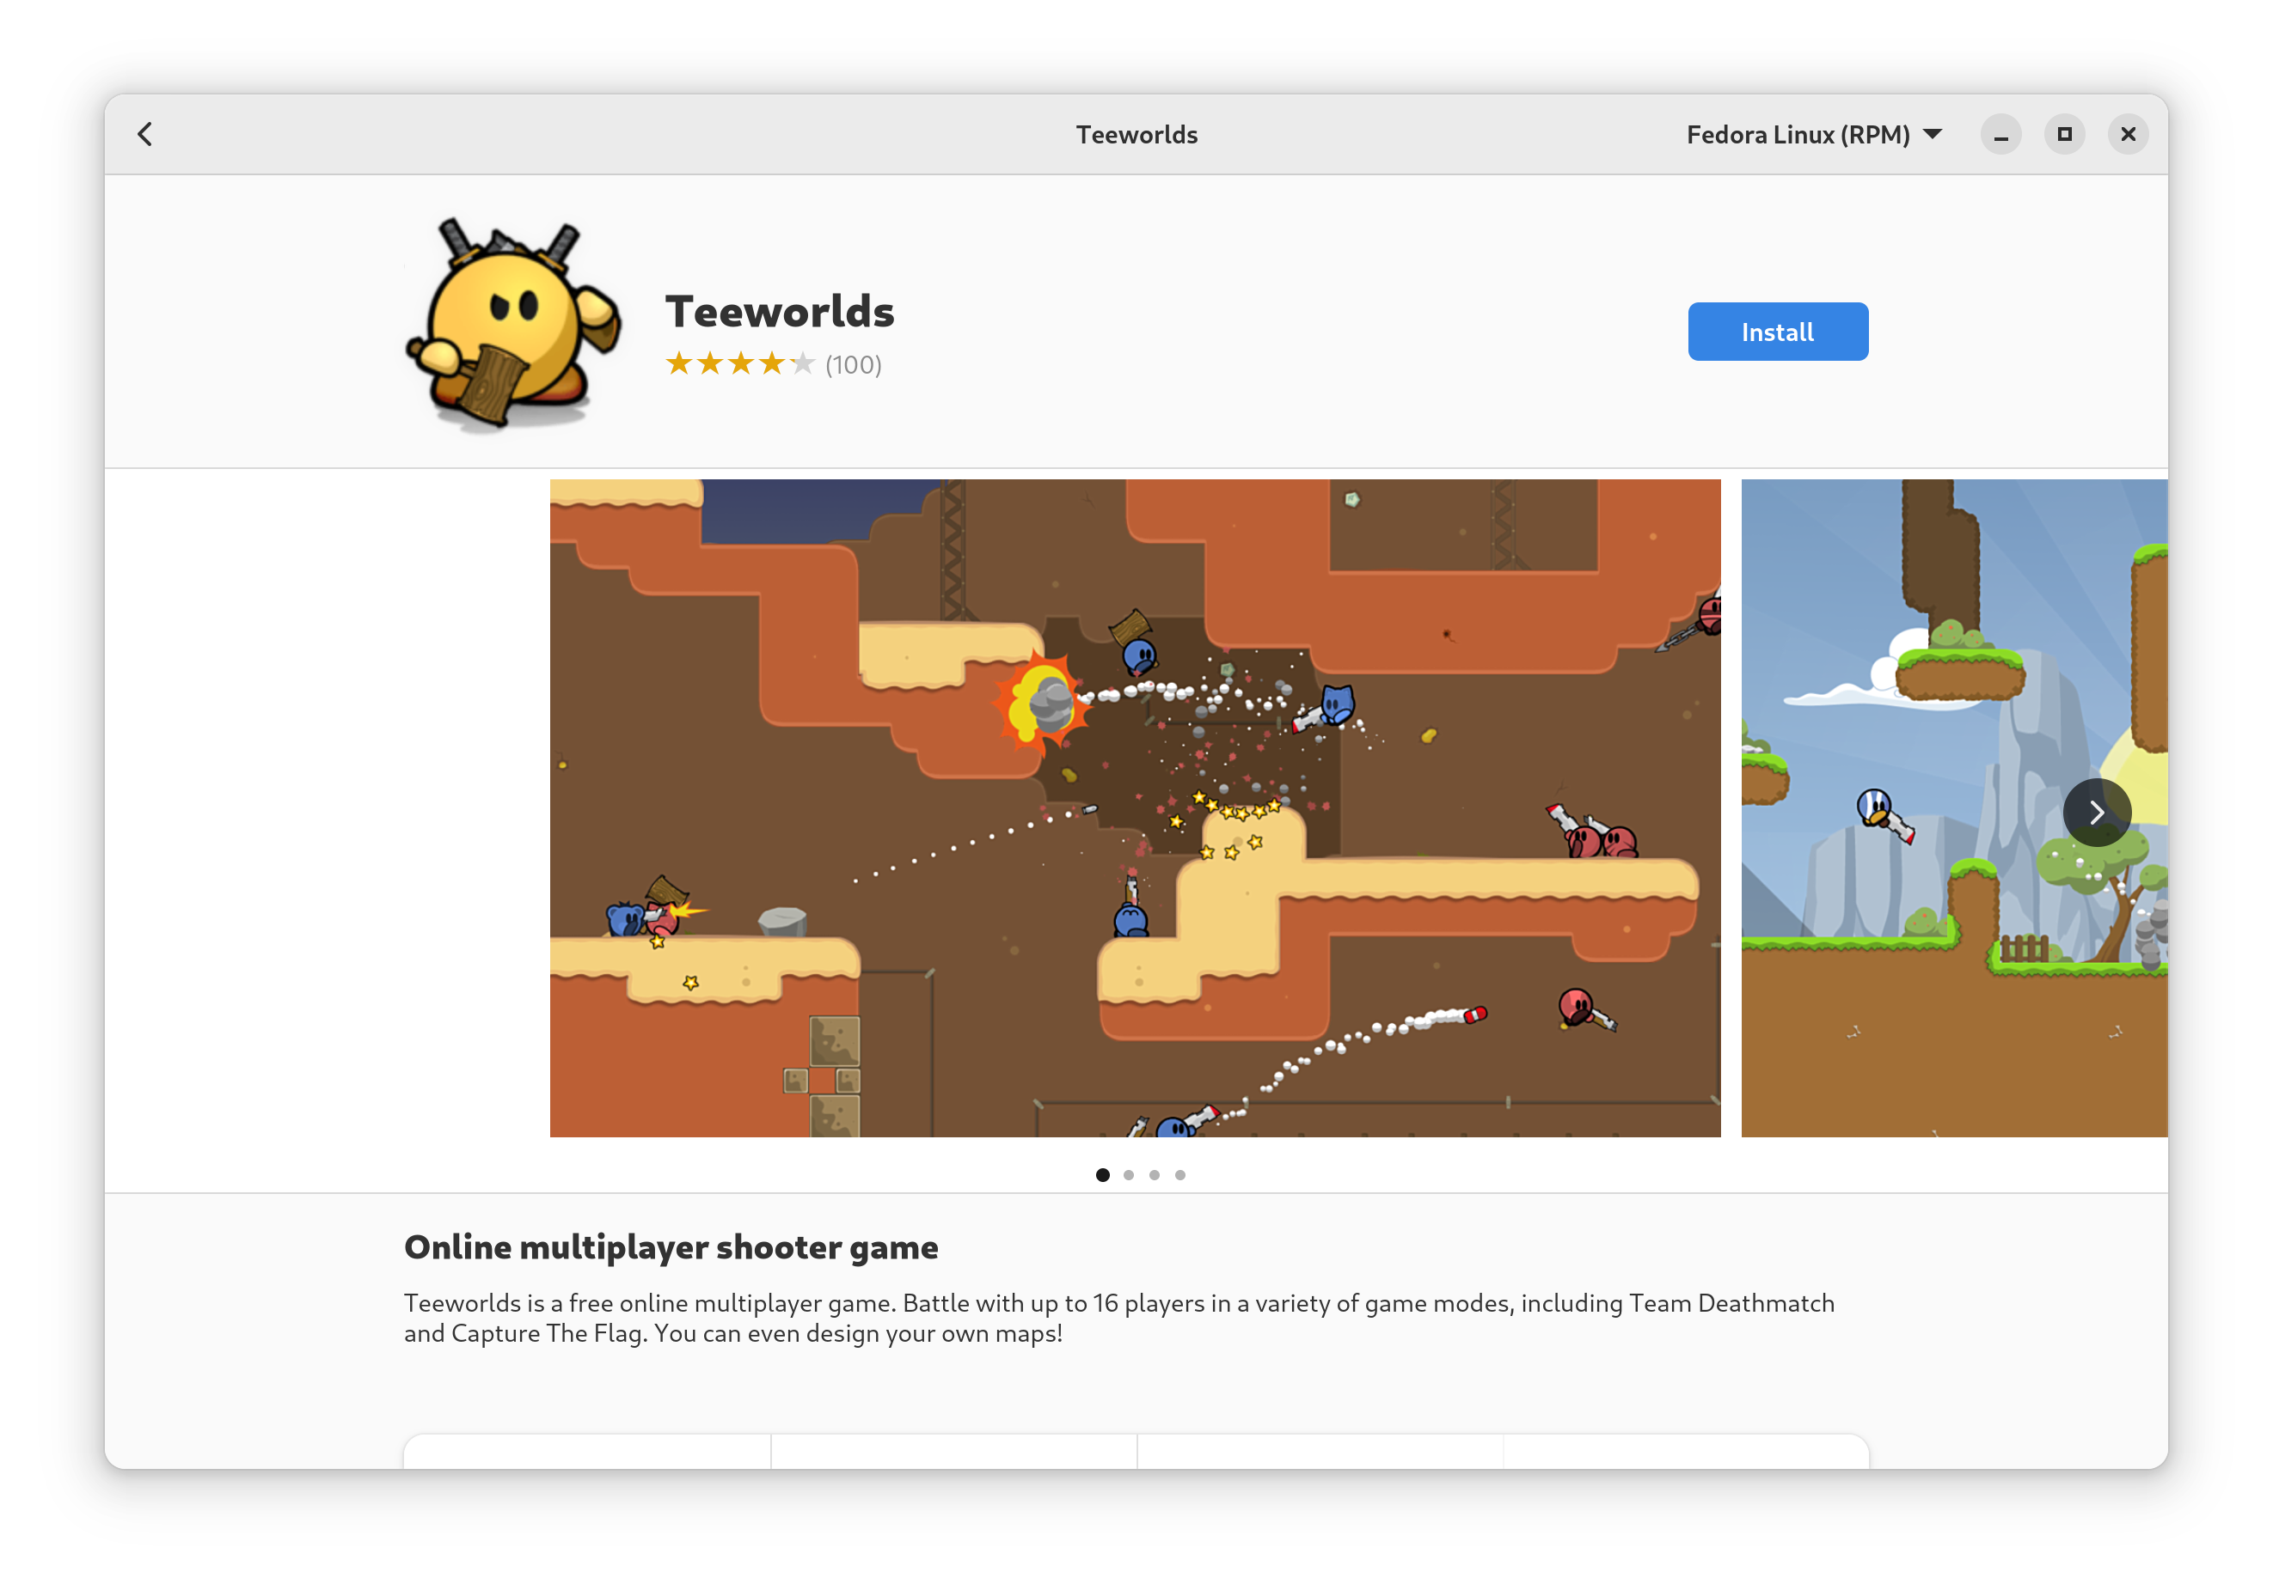
Example Output:
Step 6. Left Click the Blue “Install” Button on the right. Wait for a few seconds.
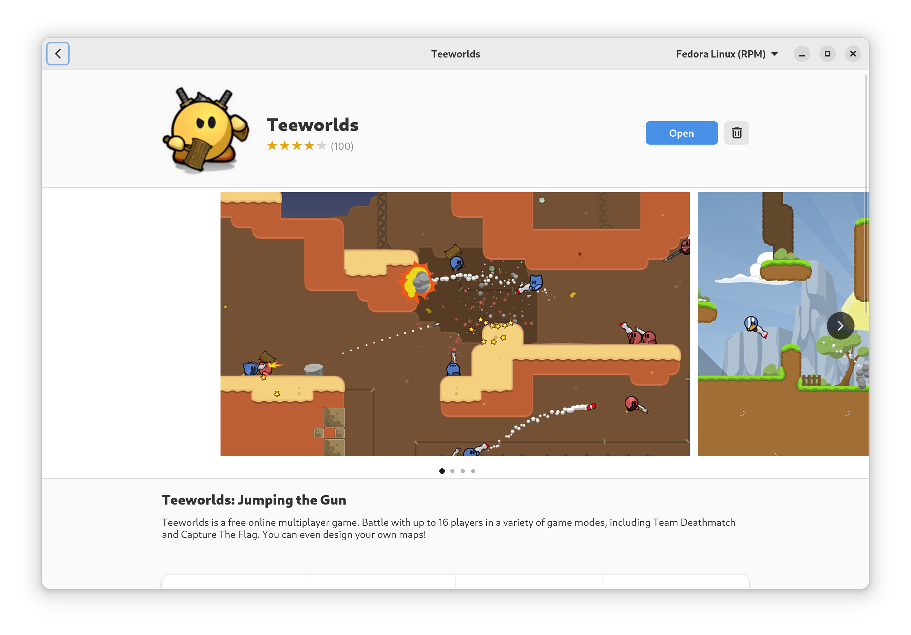
Example Output:
Step 7. Click the Blue “Open” Button to start the game!
E.N.D.

Installing with Terminal
Step 1. First, on your Fedora, move your mouse to the top-left corner of your screen.
You should see the following screen:

Example Output:

Step 2. Left Click “Type to search”.

Example Output:
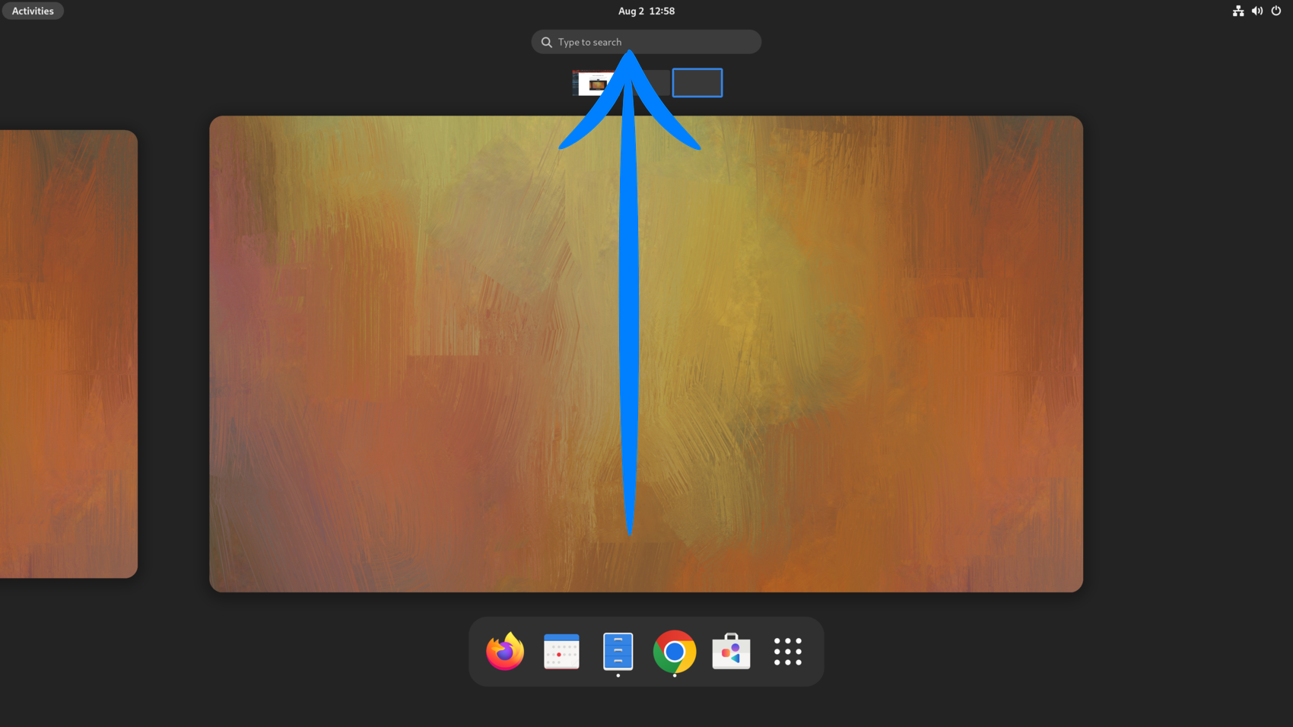
Step 3. Enter the word “Terminal”.

Example Output:
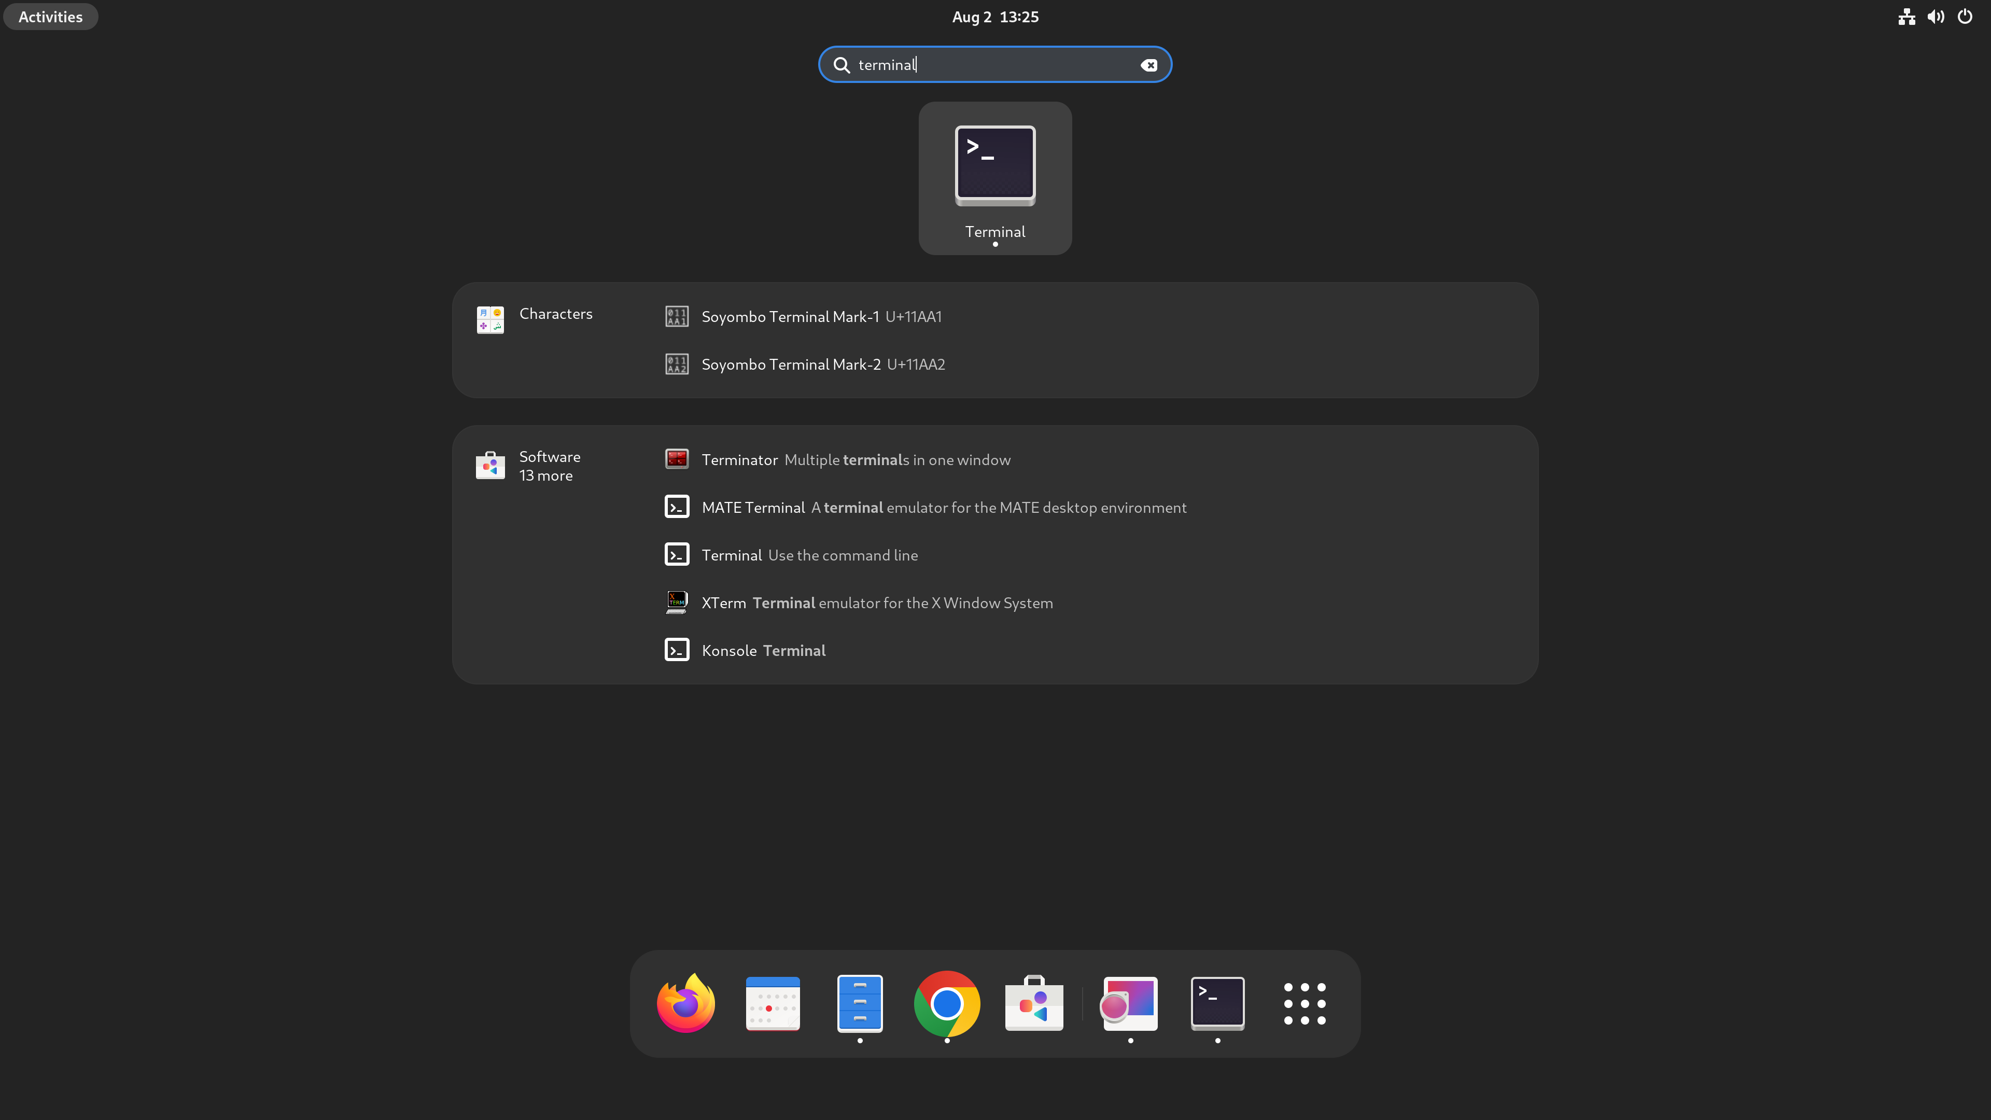

Step 4. After Left Clicking on the Terminal Icon. You should see the following terminal pop out.
Example Output:
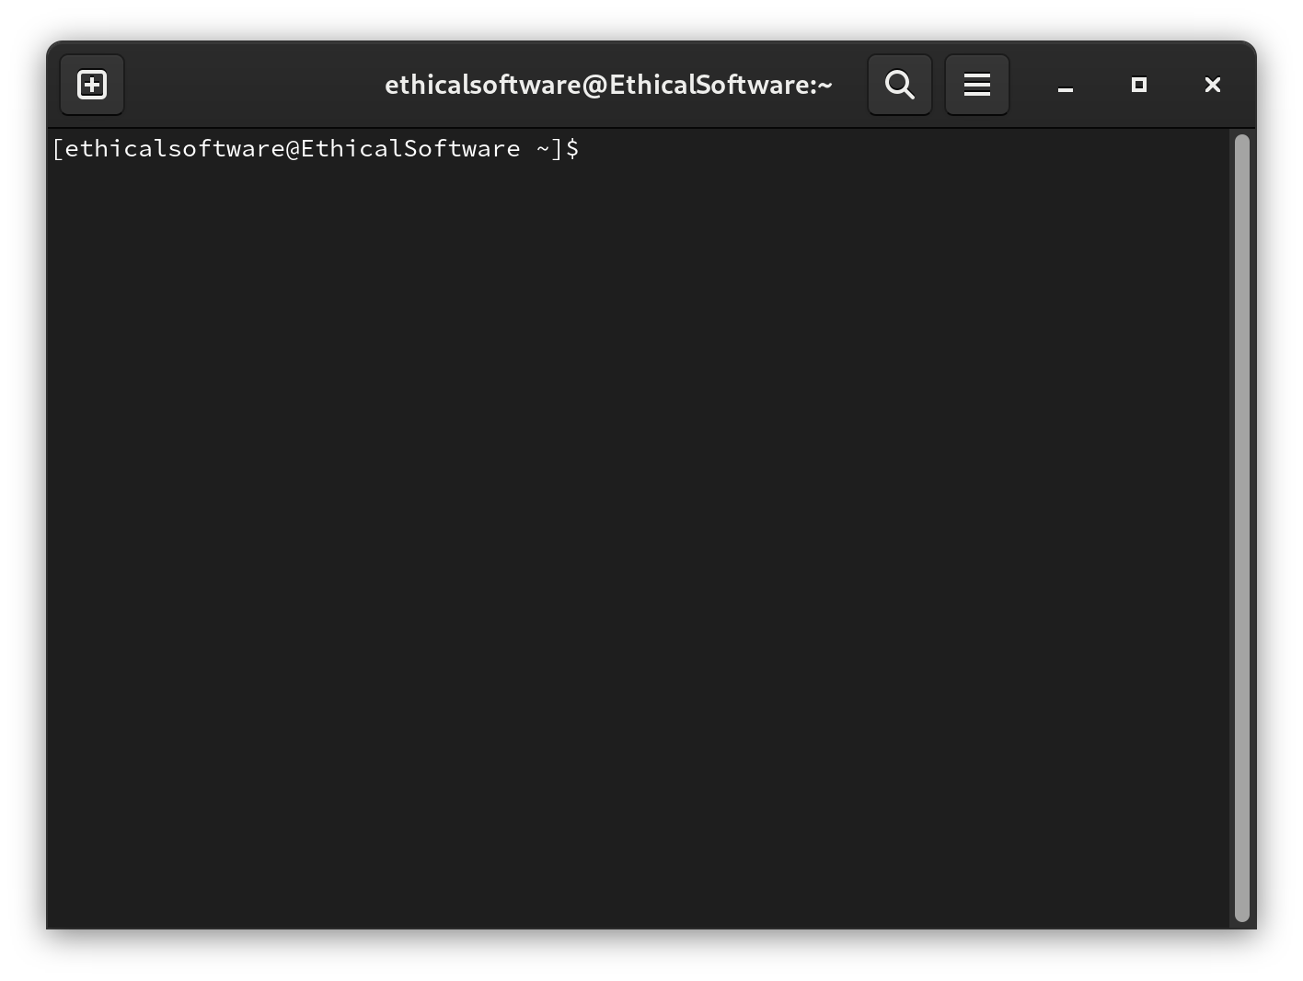

Step 5. Enter the below command in the terminal for installing the “teeworlds”package. Remember to enter your password if needed.
sudo dnf install teeworlds -y
Example Output:
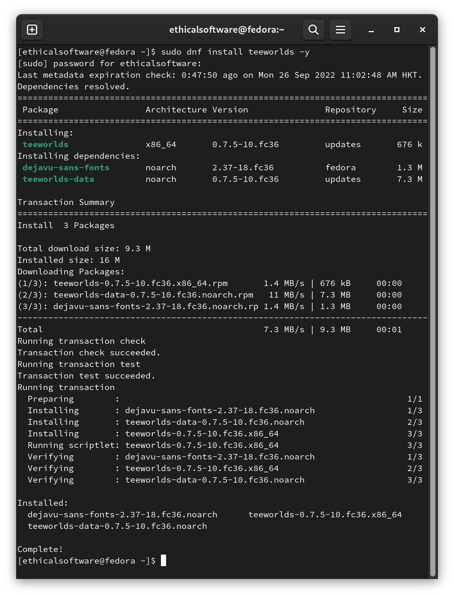
E.N.D.

